Simulation and Performance Evaluation of a Millimeter-Wave Massive-MIMO Communication Link with Beamforming and Spatial Multiplexing
Aim:
To simulate a millimeter-wave (mmWave) massive-MIMO communication system and evaluate its performance using beamforming and spatial multiplexing techniques.
Procedure:
- Open MATLAB or suitable wireless communication simulation software.
- Define the system parameters, including carrier frequency, bandwidth, number of transmit and receive antennas, and transmission power.
- Develop a massive-MIMO channel model for millimeter-wave communication.
- Implement beamforming techniques to improve signal strength and reduce interference.
- Apply spatial multiplexing to transmit multiple data streams simultaneously and analyze the received signals.
- Evaluate the system performance using spectral efficiency, signal-to-noise ratio (SNR), bit error rate (BER), and data rate.
Code:
clc;
clear;
close all;
%% 1. INPUT PARAMETERS
fc = 28e9; % Carrier frequency = 28 GHz
Nt = 16; % Number of transmit antennas
Nr = 4; % Number of receive antennas
SNR_dB = 10; % Signal-to-noise ratio = 10 dB
rho = 10^(SNR_dB/10);
lambda = 3e8/fc;
%% 2. GENERATE MIMO RAYLEIGH CHANNEL
% H is an Nr x Nt complex channel matrix
% Unit-variance Rayleigh fading channel
rng(1);
H = (randn(Nr,Nt) + 1j*randn(Nr,Nt))/sqrt(2);
% Normalize average channel power per coefficient
H = H/sqrt(mean(abs(H(:)).^2));
fprintf('MILLIMETER-WAVE MASSIVE MIMO SIMULATION\n');
fprintf('---------------------------------------\n');
fprintf('Carrier frequency : %.2f GHz\n',fc/1e9);
fprintf('Wavelength : %.4f m\n',lambda);
fprintf('Transmit antennas : %d\n',Nt);
fprintf('Receive antennas : %d\n',Nr);
fprintf('SNR : %.2f dB\n',SNR_dB);
fprintf('Channel model : Rayleigh fading\n');
fprintf('Channel matrix size : %d x %d\n',Nr,Nt);
%% 3. SINGULAR VALUE DECOMPOSITION
[U,S,V] = svd(H,'econ');
singularValues = diag(S);
M = min(Nt,Nr);
fprintf('\nCHANNEL SINGULAR VALUES\n');
disp(singularValues.');
%% 4. BEAMFORMING PERFORMANCE
% Maximum-ratio transmission and receive combining
% Use the strongest singular mode
sigmaMax = singularValues(1);
beamformingGain = sigmaMax^2;
Cbeam = log2(1 + rho*beamformingGain);
fprintf('\nBEAMFORMING RESULTS\n');
fprintf('Beamforming gain : %.4f\n',beamformingGain);
fprintf('Beamforming efficiency : %.4f bits/s/Hz\n',Cbeam);
%% 5. SPATIAL MULTIPLEXING PERFORMANCE
% Equal power allocation across M spatial streams
streamSNR = rho/M;
Cspatial = sum(log2(1 + streamSNR*singularValues.^2));
fprintf('\nSPATIAL MULTIPLEXING RESULTS\n');
fprintf('Number of spatial streams: %d\n',M);
fprintf('Spatial multiplexing efficiency: %.4f bits/s/Hz\n',Cspatial);
%% 6. MIMO CAPACITY
% Equal power allocation over all Nt transmit antennas
Ccapacity = real(log2(det(eye(Nr) + ...
(rho/Nt)*(H*H'))));
fprintf('\nMIMO CHANNEL CAPACITY\n');
fprintf('Capacity : %.4f bits/s/Hz\n',Ccapacity);
%% 7. SNR SWEEP
SNRdB_range = -10:2:30;
numSNR = length(SNRdB_range);
Cbeam_curve = zeros(1,numSNR);
Cspatial_curve = zeros(1,numSNR);
Ccapacity_curve = zeros(1,numSNR);
for k = 1:numSNR
r = 10^(SNRdB_range(k)/10);
% Single-stream beamforming
Cbeam_curve(k) = log2(1 + r*singularValues(1)^2);
% Spatial multiplexing over M streams
Cspatial_curve(k) = sum(log2(1 + ...
(r/M)*singularValues.^2));
% Equal power allocation across Nt transmit antennas
Ccapacity_curve(k) = real(log2(det(eye(Nr) + ...
(r/Nt)*(H*H'))));
end
%% 8. CAPACITY COMPARISON
figure;
plot(SNRdB_range,Cbeam_curve,'b-o','LineWidth',1.5);
hold on;
plot(SNRdB_range,Cspatial_curve,'r-s','LineWidth',1.5);
plot(SNRdB_range,Ccapacity_curve,'k-^','LineWidth',1.5);
grid on;
xlabel('SNR (dB)');
ylabel('Spectral Efficiency (bits/s/Hz)');
title('Massive MIMO Performance Comparison');
legend('Beamforming','Spatial Multiplexing', ...
'Equal-Power MIMO Capacity','Location','northwest');
%% 9. CHANNEL MATRIX MAGNITUDE
figure;
imagesc(abs(H));
colorbar;
xlabel('Transmit Antenna Index');
ylabel('Receive Antenna Index');
title('Magnitude of MIMO Channel Matrix');
%% 10. CHANNEL PHASE
figure;
imagesc(angle(H)*180/pi);
colorbar;
xlabel('Transmit Antenna Index');
ylabel('Receive Antenna Index');
title('Phase of MIMO Channel Matrix');
ylabel(colorbar,'Phase (degrees)');
%% 11. SINGULAR VALUE ANALYSIS
figure;
stem(1:M,singularValues,'filled','LineWidth',1.5);
grid on;
xlabel('Spatial Mode');
ylabel('Singular Value');
title('MIMO Channel Singular Values');
%% 12. FINAL PERFORMANCE SUMMARY
fprintf('\nFINAL PERFORMANCE SUMMARY AT %.1f dB SNR\n',SNR_dB);
fprintf('-----------------------------------------\n');
fprintf('Beamforming spectral efficiency : %.4f bits/s/Hz\n',Cbeam);
fprintf('Spatial multiplexing efficiency : %.4f bits/s/Hz\n',Cspatial);
fprintf('Equal-power MIMO capacity : %.4f bits/s/Hz\n',Ccapacity);

fprintf('\nSimulation completed successfully.\n');
Output:
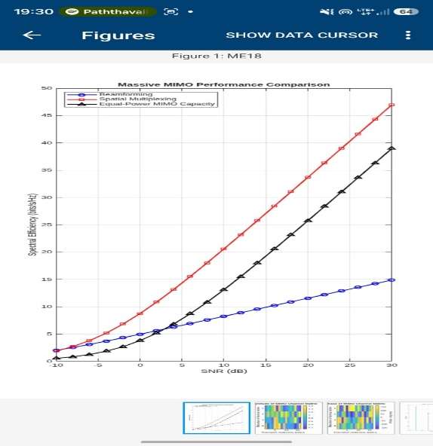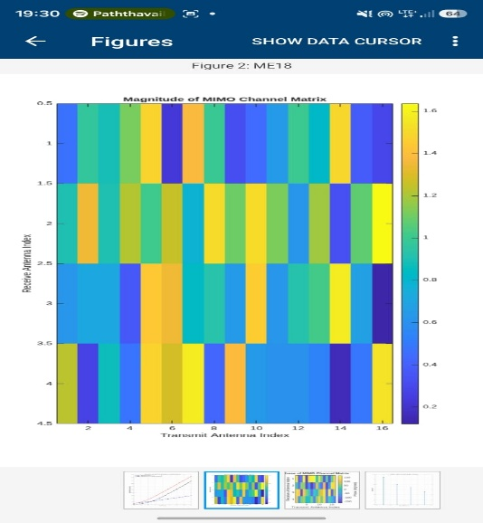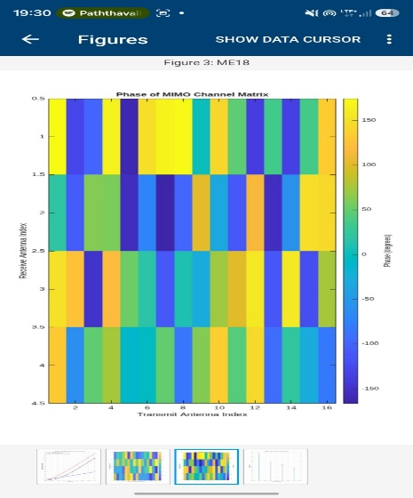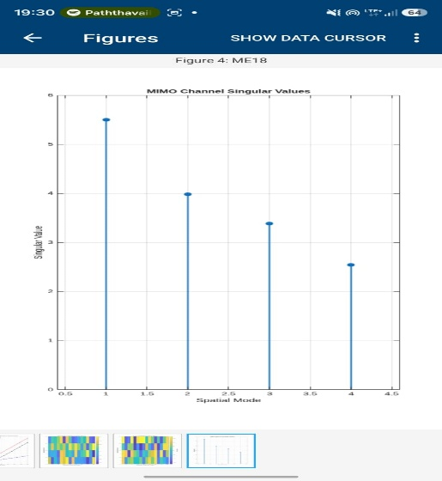
Result:
The millimeter-wave massive-MIMO communication system was simulated successfully. Beamforming and spatial multiplexing techniques were implemented and analyzed. The system performance was evaluated in terms of spectral efficiency, SNR, BER, and achievable data rate.

